SQL Server Modernisation Hack Lab Environment BUILD & RESET GUIDE
V4.0

Contents
Revision History 2
Pre-Requisites 3
READ ME FIRST! Environment Setup - Update August 2026 4
Hack Environment Architecture and Azure Components 5
Environment Setup Overview – For Information Only 6
Appendix 1 – Automated Environment Build Guide 7
PREREQUISITE: You need to install AZD on your computer 7
Download the entire labautomation folder from the same repro that also hosts the lab challenge description. 7
Confirming the database & software automated build 8
Appendix 2 – Post Environment Build Tasks 13
2.1.1 Create SQLMI Admin User 14
2.1.2 Create Shareable Links for participants 15
2.1.3 Managed Instance Set Entra ID Admin 16
Appendix 2.3 – Security Lab Build 18
Appendix 2.3.2 – Azure Defender for SQL 18
Appendix 2.4 – Monitoring Lab Build 19
Appendix 3 – Daily Environment Reset Tasks 20

Revision History

Version | Date | Author | Comments
2.0 | 2/11/19 | steve.morgan@microsoft.com | Major rewrite to include instructions for the automated environment build
2.1 | 18/5/2020 | steve.morgan@microsoft.com | Added updates in prep for sharing with partners
2.2 | 20/5/2020 | steve.morgan@microsoft.com | Removed Appendix 2: Manual Environment Build Guide
2.2.1 | 22/5/2020 | steve.morgan@microsoft.com | Embedded post build TSQL scripts.
2.2.2 | 26/5/2020 | steve.morgan@microsoft.com | Added SSIS post build tasks
2.3 | 3/6/2021 | steve.morgan@microsoft.com | Amended SSIS lab build appendix task to reflect new PowerShell based build process
3.0 | 3/21/2024 | mert.senguner@microsoft.com | Multiple corrections on various sections based on recent changes
3.1 | 3/26/2024 | mert.senguner@microsoft.com | Architecture pictures adjusted to the new setup
4.0 | 8/11/2026 | Oliver.hahn@microsoft.com | Re-Architect MicroHack and Labs

Pre-Requisites
- Azure Subscription
An existing Azure Subscription that you have Contributor rights in is needed to deploy the hack environment. You can use a One-Time PASS subscription for this. Please check the Github Repo for instructions to apply for a One-Time PASS subscription, create a tenant and associate PASS subscription with this tenant.

Important!
There are two main reasons why the lab deployment could fail:
- Policies: The MCAPSGov Deny policies will prevent the deployment of the SQL Managed Instance with SQL Authentication.
You can define an exception for the policy.

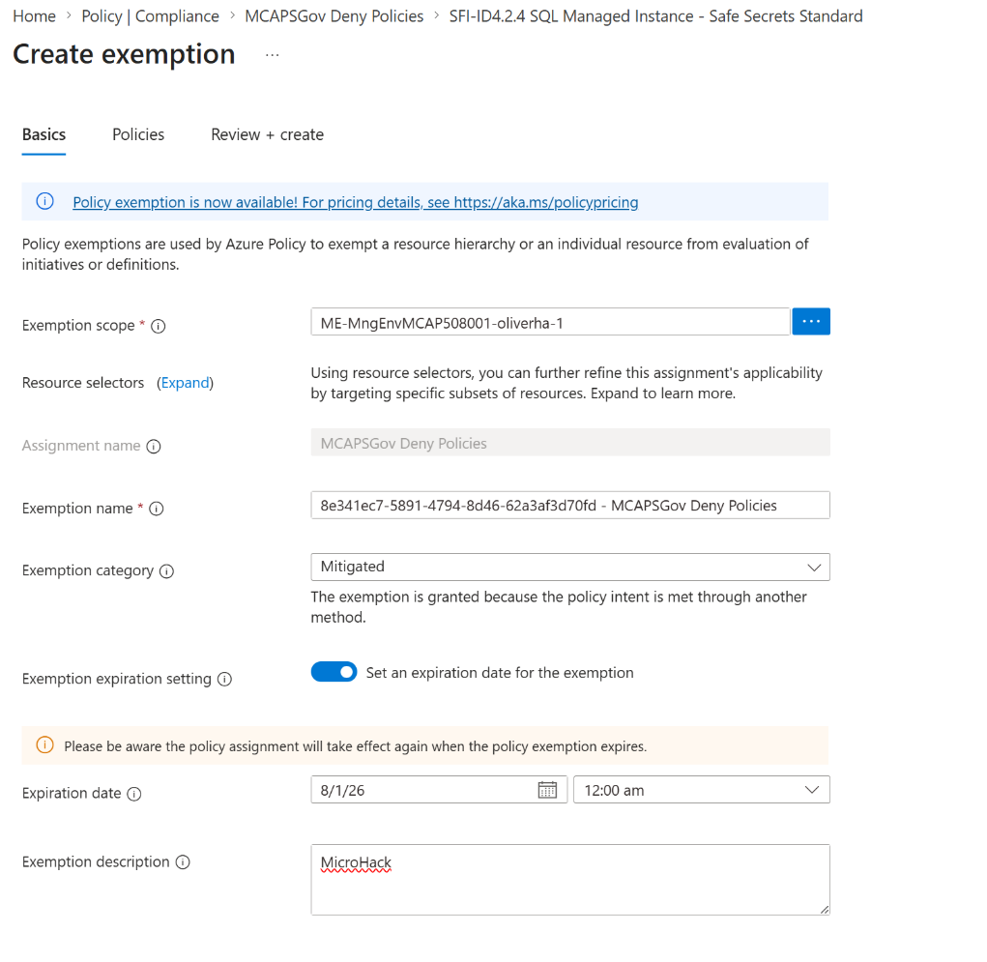

- Quota: We strongly recommend to not deploy the lab on Western or Northern Europe.
I am currently using swedencentral. Maybe you want to leverage a region that is closer to you.

READ ME FIRST! Environment Setup - Update August 2026
The set-up of the hack environment (as shown in the architecture diagram) has been simplified and largely automated using AZD (Azure Developer CLI) and bicep templates.

Instructions for the automated build process can be found here:
Appendix 1 – Automated Environment Build Guide

There are some manual tasks that need to be completed after the build process.
See Appendix 2 – Post Environment Build Tasks for details

If reusing the environment for subsequent runs of the hack there are some tasks that need to be performed to rest the environment.
See Appendix 3 – Daily Environment Reset Tasks for details

Hack Environment Architecture and Azure Components

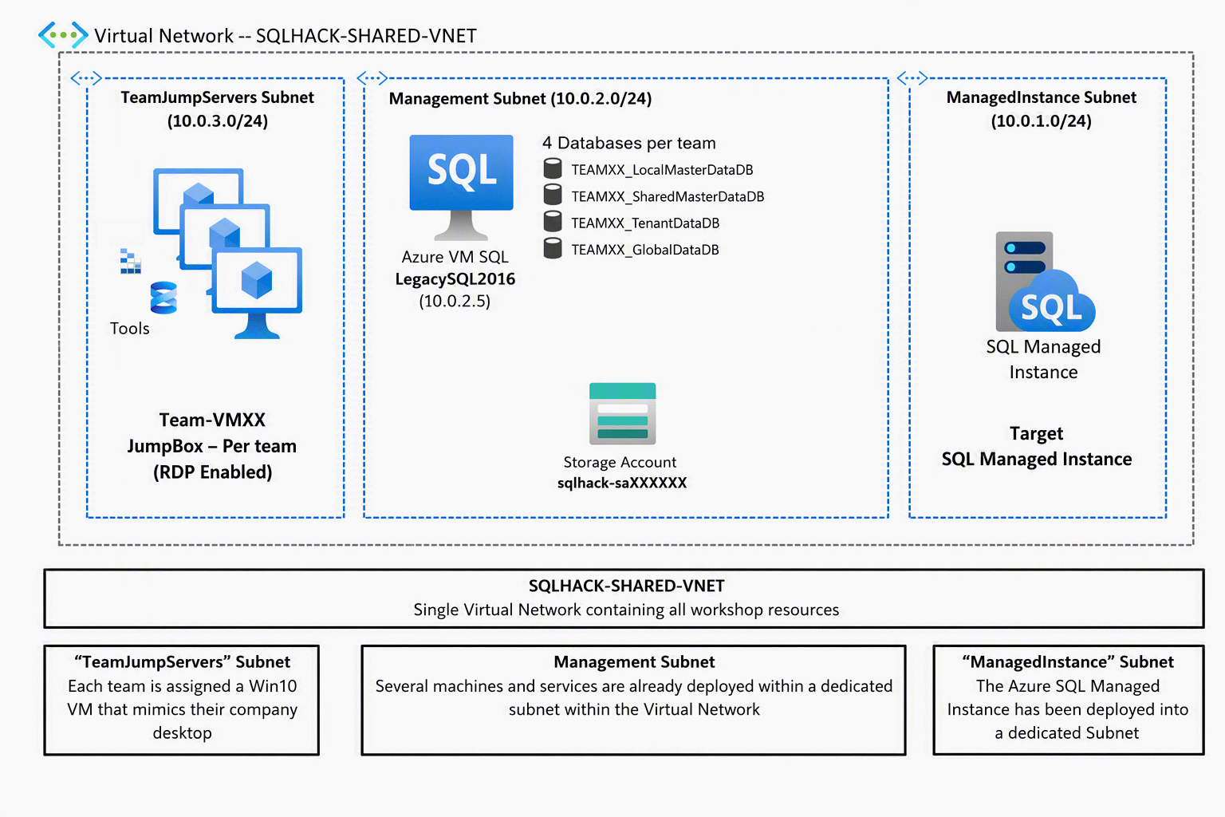

Environment Setup Overview – For Information Only
This is the high-level build process performed by the PowerShell script and ARM templates.

This section is for information only and you can skip straight to Appendix 1 – Automated Environment Build Guide to begin the environment build.

NOTE: All resources should be created in the same region (E.g. North Europe)

- Create Resource Groups and VNET
  - The entire deployment uses one resource group and one VNET
  - The VNET has 5 subnets for:
    - Managed Instance
    - Management
    - Teams VMs
    - Bastion
    - Private Endpoints
- Create Azure SQL Managed Instance
  - The Managed Instance could take several hours to provision.
- Create SQL2016 legacy environment
  - This VM mimic an on-premises legacy SQL Server 2016
  - The TEAM databases will already be restored on the SQL Server 2016
- The Storage Account will only be used during the deployment process
  - The migration will be performed by using the SSMS 22 migration capabilities with MI Link
- Create team Win11 VM used by workshop attendees for labs
  - Install SQL Server Management Studio on each Win11 VM

Appendix 1 – Automated Environment Build Guide

PREREQUISITE: You need to install AZD on your computer

Download the entire labautomation folder from the same repro that also hosts the lab challenge description.
- Download the complete environment from this GIT repository from Master branch:
MicroHack/03-Azure/01-02 Data/02-SQL_Modernization at main · microsoft/MicroHack

- Open the “labautomation” folder in the unzipped/downloaded repository

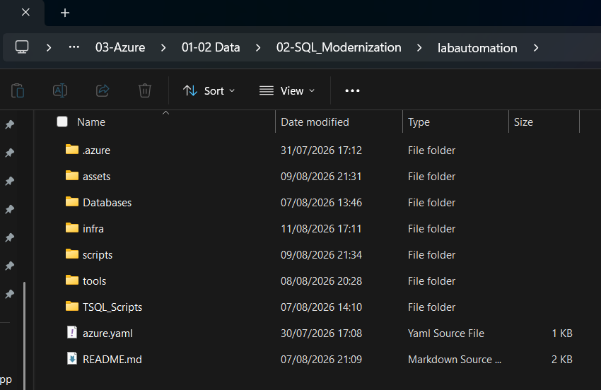

The folder contains a README with detailed information.

- Open an administrative Terminal window and connect to your Azure Tenant:
azd auth login --tenant-id "MngEnvMCAPxxxxxx.onmicrosoft.com"
With AZD you can store session information for later reuse. AZD will store session information on the disk under the subfolder .azure.
If you want to start from scratch, you can delete the folder.
azd init -e sqlhack

You can already define additional information like subscription and azure region in environment variables for your session. Otherwise, the provisioning will ask for missing information.

azd env set AZURE_SUBSCRIPTION_ID "xxxxxxxx-yyyy-zzzz-yyyy-xxxxxxxxxxxx"
azd env set AZURE_LOCATION swedencentral

You start the provisioning with:
azd provision

The script will ask for additional required parameters:

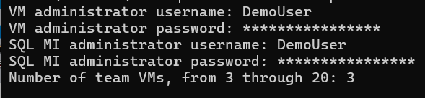
For the Admin username and password we strongly recommend you use the following account details as these are reflected in the Labs Guides that users follow.
Username | DemoUser
Password | Demo@pass1234567

The deployment will normally run 20 – 30 minutes. In some cases, it can even take more than an hour. You can follow all activity in the Azure resource group under deployments.

At the end of the deployment, you should receive an information that the deployment was successful.

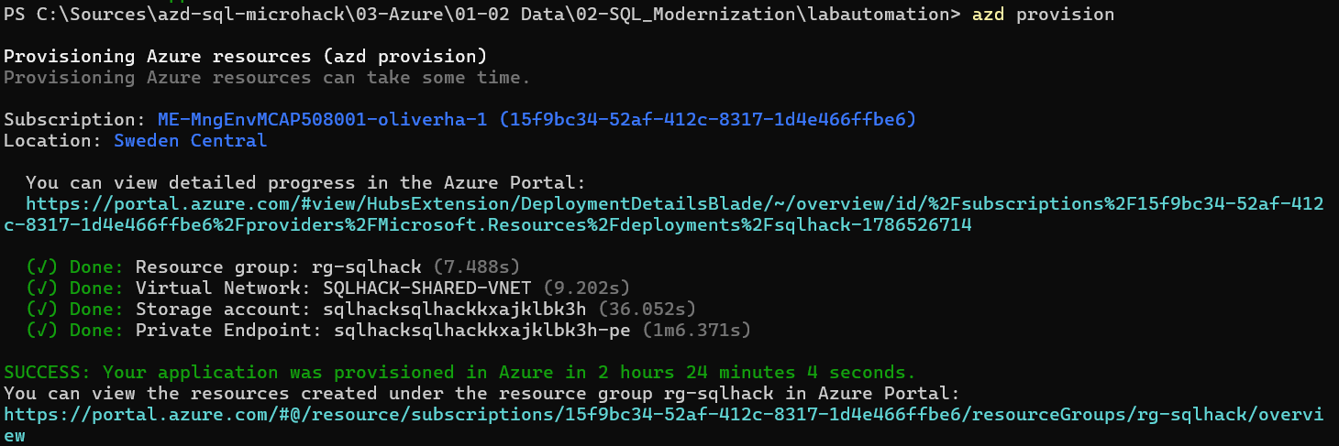

With the command “azd env get-values” you can get a list of all exported information of the generated environment.
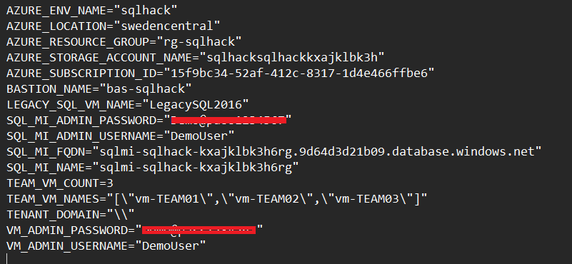

If there were errors during the deployment, you can check the transcript logs on the virtual machines:
- Legacysql2016 contains transcripts for the following actions:
  - Set Firewall rules for all SQL Server instances
  - Restore Team Databases
  - Configure legacy SQL Server
  - Install Azure CLI
  - Restore Team Databases on SQL MI
- arcSQL2022 contains transcripts for the following actions:
  - Set Firewall rules for all SQL Server instances
  - Restore Sample Database on SQL Server 2022
- TEAM VMs contain transcripts for the following actions:
  - Installing Team Tools
  - Downloading Sample files
  - Configuring Team Shortcuts

In general, it will be easier to remove the current deployment and to re-deploy everything.

You can purge the current deployment with the command “azd down –purge”

All manual tasks from the past are no longer required.

Confirming the database & software automated build
- Make sure one of the Win11 VMs is started & RDP onto it using either your username & password or the default account “DemoUser”, password “Demo@pass1234567”

- On one of the Win11VMs check that the following software & artefacts are installed:

Artefact | Location | Notes
SQL Server Management Studio 22 | Desktop Shortcut
Storage Explorer | (Start Menu)
Azure Data Studio | (Start Menu)

- Launch SSMS and connect to the LEGACYSQL2016 server using windows authentication. The server VM and SQL instance may need to be started.

Check that 4 databases per team have been created.
This confirms the LEGACYSQL2016 VM has been built and the databases deployed.

If the databases have not been restored follow below instructions

The databases are located on the legacysql2016 machine in folder C:\SQLBackups
You can manually restore the databases for each team and rename the destination database:

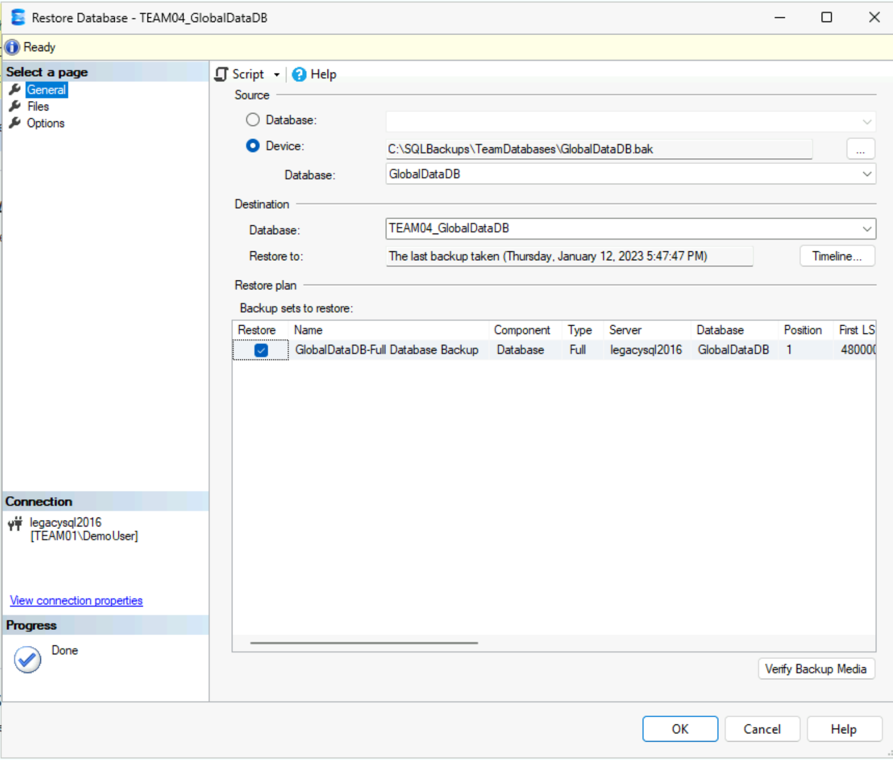

Now go to Appendix 2 – Post Environment Build Tasks to complete a number of minor manual configuration tasks.

This page intentionally blank

Appendix 2 – Post Environment Build Tasks
Once the automated build has completed there are some tasks that need to be performed manually.
This appendix details those tasks.

2.1.1 Create SQLMI Admin User
Leverage Global Admin permissions to grant SQL MI Admin User Contributor rights on the MicroHack resource group. If the SQL MI Admin user already exists in Entra ID, you only need to grant contributor permissions to the MicroHack resource group.
If you are using a new Tenant, please create the SQL MI Admin account first.
User-Name: sqlmi-hack-admin
Password: Demo@sqlmi1234567
Please make sure that you set exceptions for the conditional access policies, so that the account does not require MFA and also no additional security info registration:
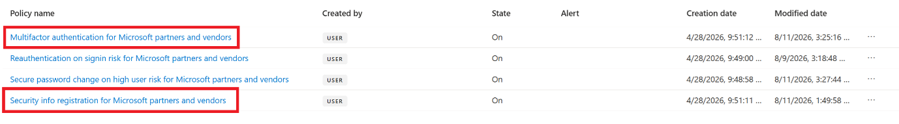
Also make sure that the account does not need to change the password after the first logon.
Make the account contributor for the MicroHack resource group rg-sqlhack:
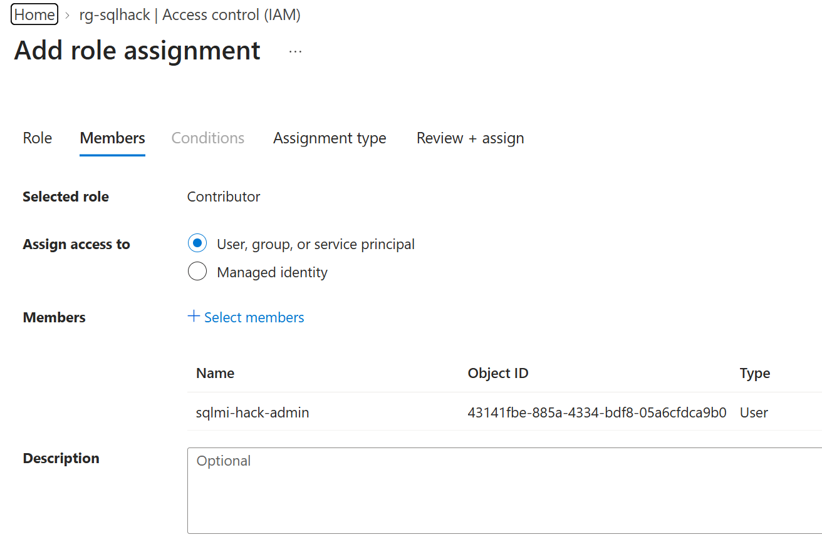
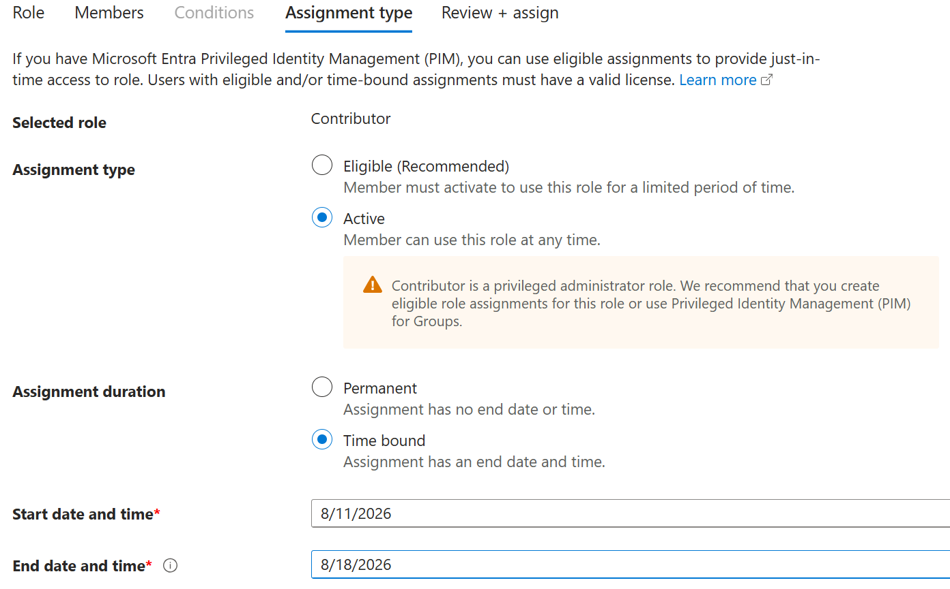

2.1.2 Create Shareable Links for participants

In the Bastion configuration you can create shareable links so that participants do not need to connect to the azure portal.

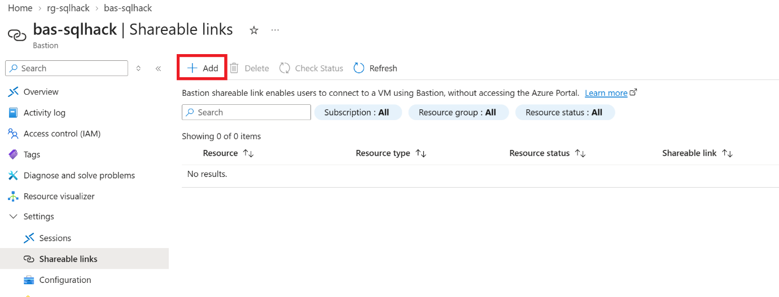

Just create shareable links for all machines:
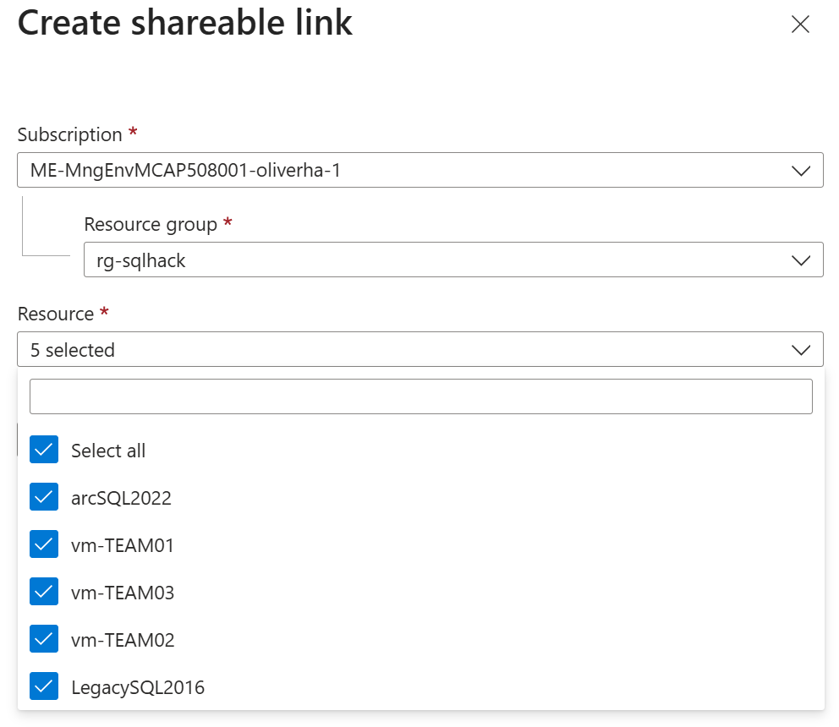

The links should be valid for 7 days:
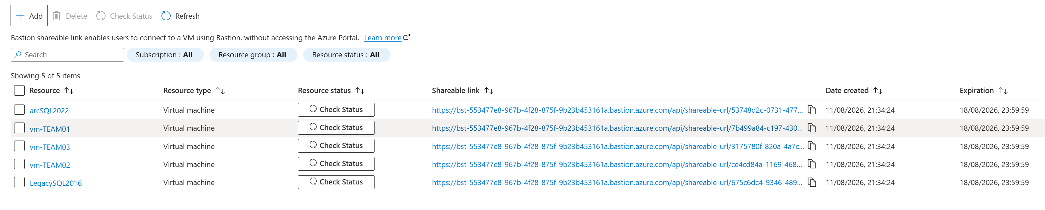

2.1.3 Managed Instance Set Entra ID Admin
The Managed Instance will not have an Entra ID Admin account configured. After deployment you should enable Entra ID Admin by using a user that has sufficient permissions in Entra ID.
You may need to activate Global Admin rights to perform this action.

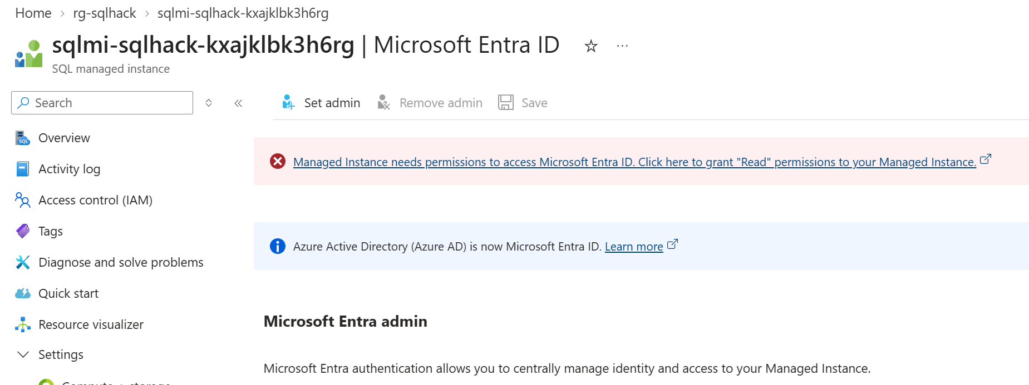

First, you need to grant Directory Reader permission to the SQL MI System Managed Identity
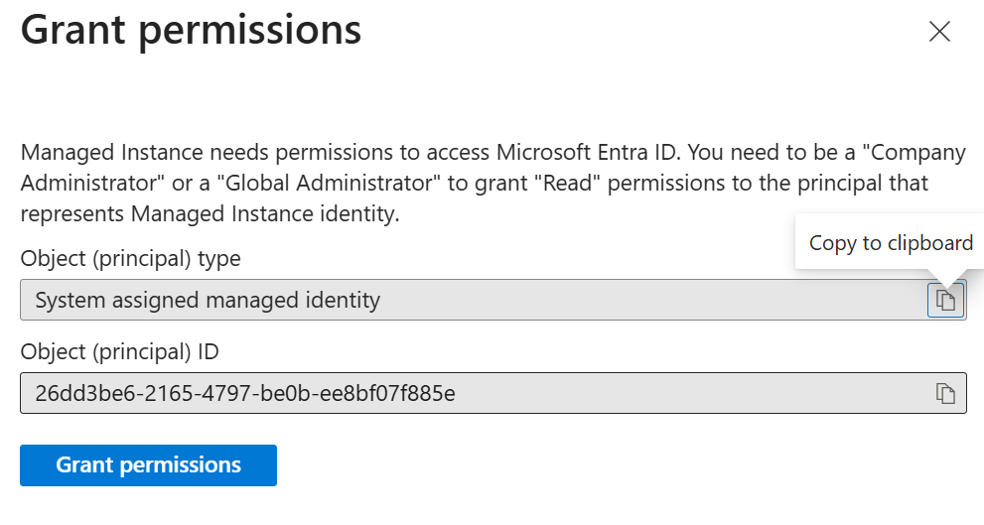

After that you can set the Entra ID Admin

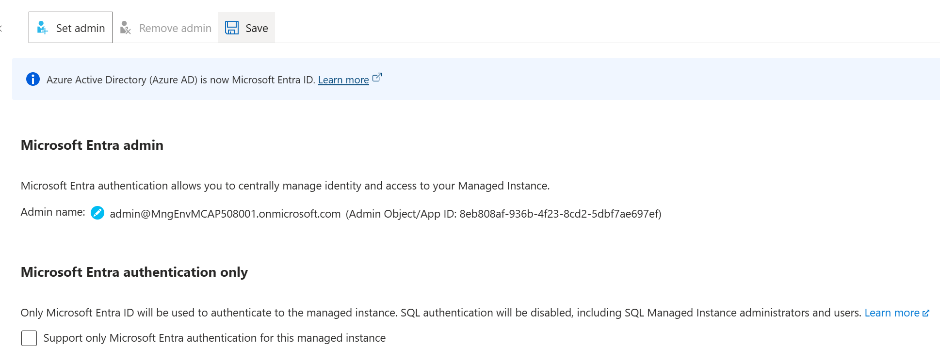

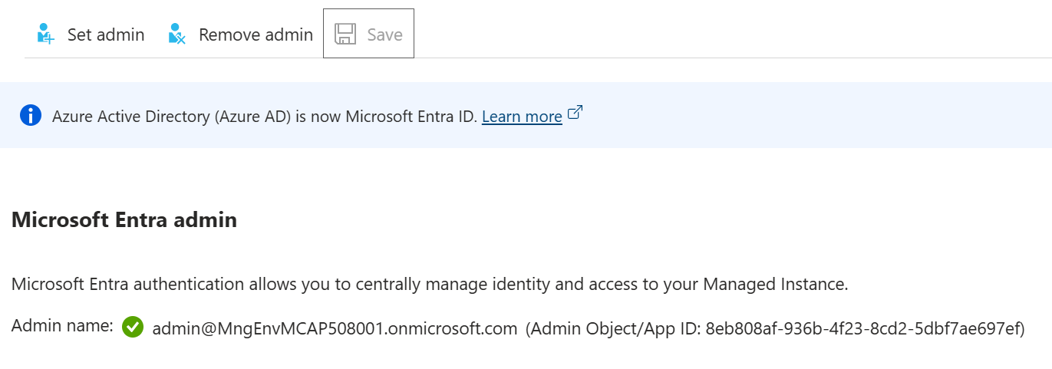

Appendix 2.3 – Security Lab Build

Appendix 2.3.2 – Azure Defender for SQL
For part 4 of the Security labs Azure Defender for SQL must be enabled on the shared SQL Managed Instance through the SQLMI Security Centre screen.

Appendix 2.4 – Monitoring Lab Build

Appendix 3 – Daily Environment Reset Tasks
If the hack environment is to be reused, a number of quick tasks need to be performed to reset the environment for another run:
Start Win11 VMs  (set to shut down at 6pm UTC) | Do this manually through the Azure Portal
Start LEGACYSQL2016 VMs  (set to shut down at 6pm UTC) | Do this manually through the Azure Portal
Delete migrated DBs & migrated logins from the SQL MI | Run SQL Managed Instance Environment Reset TSQL script (below) to drop all previously migrated DBs and logins.
Check location Wi-Fi allows RDP | RDP outbound may not be enabled if doing a closed/private hack. With Bastion you don’t need to take an action.

This page intentionally blank

